Obtain permission from instructor before operating this machine |  | Disc Sander

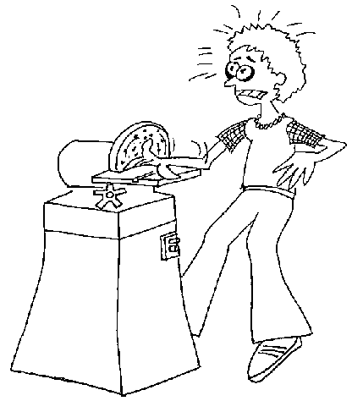

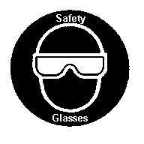

Safety suggestions
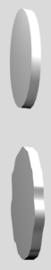
- Eye protection must be worn at all times.
shape various material
- Tilt the table downward only, when sanding bevels.
- Restrain loose clothing and hair.
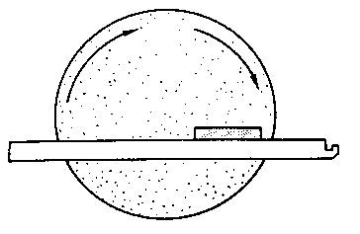
- Keep fingers at least 2” (50mm.) away from the abrasive surface.
- Sand only on the downward moving side of the disc.

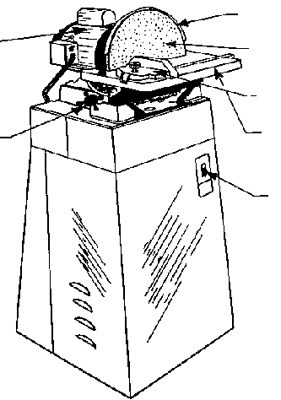
Motor
Table tilt lock
Disc guard
Sanding disc
Mitre gage
Table
Power switch

Disc Sander

Name …………………..

Class …………………….

Date ………………………

Safety Quiz

1. | Eye protection is not required when disc sanding. | T | F
2. | Moderate pressure only, should be used. | T | F
3. | It is safe to tilt the table. | T | F
4. | A crepe rubber block is used to clean the disc.  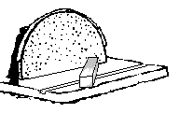 | T | F
5. | Long hair and loose clothing are hazardous when disc sanding. | T | F
6. | Sanding on the upward moving side of the disc can result in a loss of control and an accident.  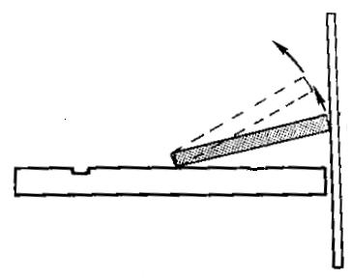  1.  2.  3.  4.  5.  6.  7. | T | F

