Editing safety sheets:

These documents were created with MS Word 2000. The graphics are either digital photos, scanned or original graphics.
As such modifications to suit your own needs are easily done.

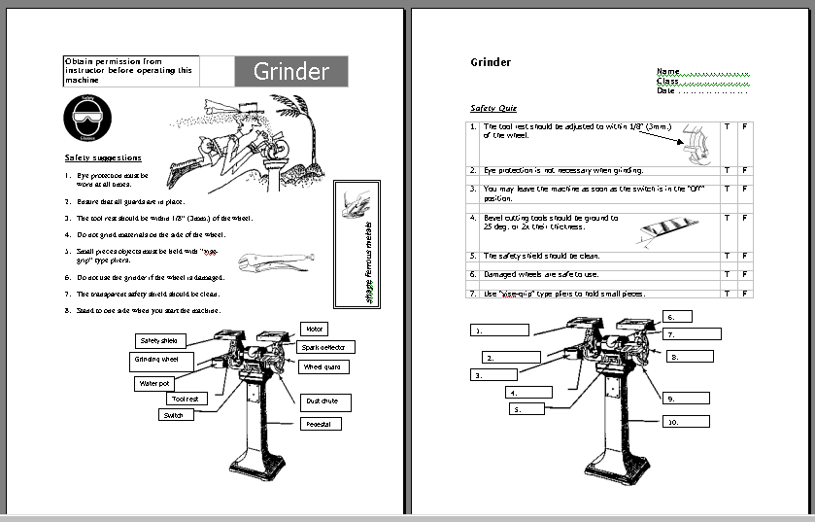

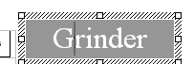

To change the title:
- Select the title
(notice it is a text box)
- Insert the cursor and edit
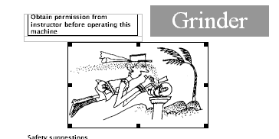

To change a graphic:
- Select the graphic
(it is a JPEG) file.
- Change as needed

The sample is a text box with a contained graphic:
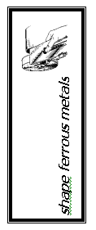
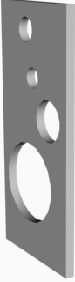

Most of the graphics are images created with 3DS Max.

Safety suggestions are done as a numbered list. To change them:
- Highlight the section you wish to delete, delete it.
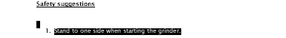
- Type the new text.
- Each time you return, the next number will appear

The Safety Quiz is a table
To change it :
- Select the table, modify rows, columns or cells as needed.
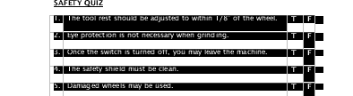

- Numbers and text are easily changed by inserting the cursor and backspacing or highlighting and deleting.

The unlabeled machine graphic, has individual rectangles for each label

To change, select and modify

