Rope

Section I. Fiber Rope
In the fabrication of fiber rope, a number of fibers of various plants are twisted together to form yarns. These yarns are then twisted together in the opposite direction of the fibers to form strands (see Figure 1-1). The strands are twisted in the opposite direction of the yarns to form the completed rope. The direction of twist of each element of the rope is known as the "lay" of that element. Twisting each element in the opposite direction puts the rope in balance and prevents its elements from unlaying when a load is suspended on it. The principal type of fiber rope is the three-strand, right lay, in which three strands are twisted in a right-hand direction. Four-strand ropes, which are also available, are slightly heavier but are weaker than three-strand ropes of the same diameter.
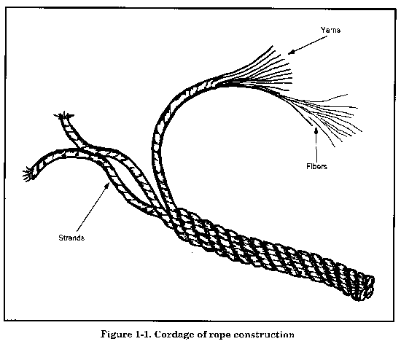

TYPES OF FIBERS
The term cordage is applied collectively to ropes and twines made by twisting together vegetable or synthetic fibers.

VEGETABLE FIBERS
The principal vegetable fibers are abaca (known as Manila), sisalana and henequen (both known as sisal), hemp, and sometimes coir, cotton, and jute. The last three are relatively unimportant in the heavy cordage field.
Abaca, sisalana, and henequen are classified as hard fibers. The comparative strengths of the vegetable fibers, considering abaca as 100, are as follows:
- Sisalana | 80
- Henequen | 65
- Hemp | 100
Manila
This is a strong fiber that comes from the leaf stems of the stalk of the abaca plant, which belongs to the banana family. The fibers vary in length from 1.2 to 4.5 meters (4 to 15 feet) in the natural states. The quality of the fiber and its length give Manila rope relatively high elasticity, strength, and resistance to wear and deterioration. The manufacturer treats the rope with chemicals to make it more mildew resistant, which increases the rope's quality. Manila rope is generally the standard item of issue because of its quality and relative strength.
Sisal
Sisal rope is made from two tropical plants, sisalana and henequen, that produce fibers 0.6 to 1.2 meters (2 to 4 feet) long. Sisalana produces the stronger fibers of the two plants, so the rope is known as sisal. Sisal rope is about 80 percent as strong as high quality Manila rope and can be easily obtained. It withstands exposure to sea water very well and is often used for this reason.
Hemp
This tall plant is cultivated in many parts of the world and provides useful fibers for making rope and cloth. Hemp was used extensively before the introduction of Manila, but its principal use today is in fittings, such as ratline, marline, and spun yarn. Since hemp absorbs much better than the hard fibers, these fittings are invariably tarred to make them more water-resistant. Tarred hemp has about 80 percent of the strength of untarred hemp. Of these tarred fittings, marline is the standard item of issue.
Coir and Cotton
Coir rope is made from the fiber of coconut husks. It is a very elastic, rough rope about one-fourth the strength of hemp but light enough to float on water. Cotton makes a very smooth white rope that withstands much bending and running. These two types of rope are not widely used in the military; however, cotton is used in some cases for very small lines.
Jute
Jute is the glossy fiber of either of two East Indian plants of the linden family used chiefly for sacking, burlap, and cheaper varieties of twine and rope.

SYNTHETIC FIBERS
The principal synthetic fiber used for rope is nylon. It has a tensile strength nearly three times that of Manila. The advantage of using nylon rope is that it is waterproof and has the ability to stretch, absorb shocks, and resume normal length. It also resists abrasion, rot, decay, and fungus growth.

CHARACTERISTICS OF FIBER ROPE
Fiber rope is characterized by its size, weight, and strength.
SIZE
Fiber rope is designated by diameter up to 5/8 inch, then it is designated by circumference up to 12 inches or more. For this reason, most tables give both the diameter and circumference of fiber rope.
WEIGHT
The weight of rope varies with use, weather conditions, added preservatives, and other factors. Table 1-1, lists the weight of new fiber rope.
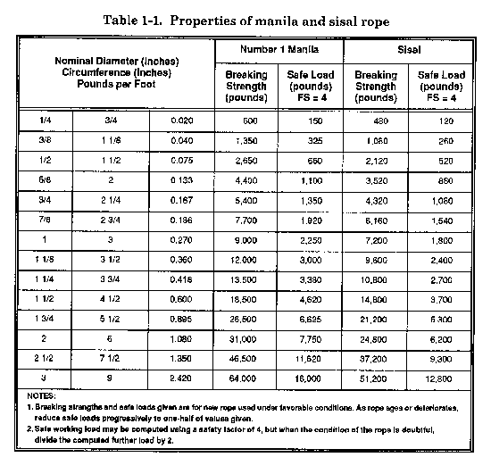

STRENGTH
Table 1-1 lists some of the properties of Manila and sisal rope, including the breaking strength (BS), which is the greatest stress that a material is capable of withstanding without rupture. The table shows that the minimum BS is considerably greater than the safe load or the safe working capacity (SWC). This is the maximum load that can safely be applied to a particular type of rope. The difference is caused by the application of a safety factor. To obtain the SWC of rope, divide the BS by a factor of safety (FS):
SWC = BS/FS
A new 1-inch diameter, Number 1 Manila rope has a BS of 9,000 pounds (see Table 1-1). To determine the rope's SWC, divide its BS (9,000 pounds) by a minimum standard FS of 4. The result is a SWC of 2,250 pounds. This means that you can safely apply 2,250 pounds of tension to the new l-inch diameter, Number 1 Manila rope in normal use. Always use a FS because the BS of rope becomes reduced after use and exposure to weather conditions. In addition, a FS is required because of shock loading, knots, sharp bends, and other stresses that rope may have to withstand during its use. Some of these stresses reduce the strength of rope as much as 50 percent. If tables are not available, you can closely approximate the SWC by a rule of thumb. The rule of thumb for the SWC, in tons, for fiber rope is equal to the square of the rope diameter (D) in inches:
SWC = D²
The SWC, in tons, of a 1/2-inch diameter fiber rope would be 1/2 inch squared or 1/4 ton. The rule of thumb allows a FS of about 4.

CARE OF FIBER ROPE
The strength and useful life of fiber rope is shortened considerably by improper care. To prolong its life and strength, observe the following guidelines:
- Ensure that it is dry and then stored in a cool, dry place. This reduces the possibility of mildew and rotting.
- Coil it on a spool or hang it from pegs in a way that allows air circulation.
- Avoid dragging it through sand or dirt or pulling it over sharp edges. Sand or grit between the fibers cuts them and reduces the rope's strength.
- Slacken taut lines before they are exposed to rain or dampness because a wet rope shrinks and may break.
- Thaw a frozen rope completely before using it; otherwise the frozen fibers will break as they resist bending.
- Avoid exposure to excessive heat and fumes of chemicals; heat or boiling water decreases rope strength about 20 percent.

HANDLING OF FIBER ROPE
New rope is coiled, bound, and wrapped in burlap. The protective covering should not be removed until the rope is to be used. This protects it during storage and prevents tangling. To open the new rope, strip off the burlap wrapping and look inside the coil for the end of the rope. This should be at the bottom of the coil (see Figure 1-2). If it is not, turn the coil over so the end is at the bottom. Pull the end up through the center of the coil. As the rope comes up, it unwinds in a counterclockwise direction.
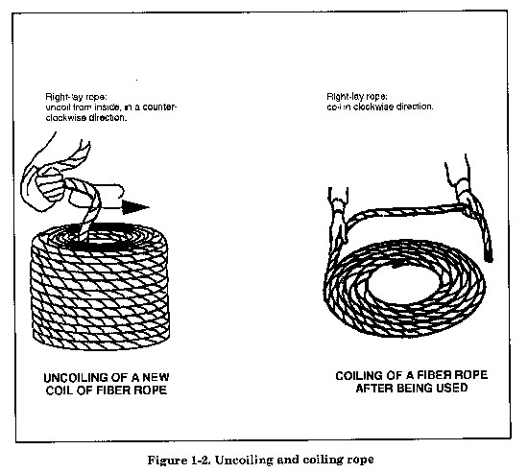

INSPECTION OF FIBER ROPE
The outside appearance of fiber rope is not always a good indication of its internal condition. Rope softens with use. Dampness, heavy strain, fraying and breaking of strands, and chafing on rough edges all weaken it considerably. Overloading rope may cause it to break, with possible heavy damage to material and serious injury to personnel. For this reason, inspect it carefully at regular intervals to determine its condition. Untwist the strands slightly to open a rope so that you can examine the inside. Mildewed rope has a musty odor and the inner fibers of the strands have a dark, stained appearance. Broken strands or broken yarns ordinarily are easy to identify. Dirt and sawdust-like material inside a rope, caused by chafing, indicate damage. In rope having a central core, the core should not break away in small pieces when examined. If it does, this is an indication that a rope has been overstrained.
If a rope appears to be satisfactory in all other respects, pull out two fibers and try to break them. Sound fibers should offer considerable resistance to breakage. When you find unsatisfactory conditions, destroy a rope or cut it up in short pieces to prevent its being used in hoisting. You can use the short pieces for other purposes.

Knots, Splices, Attachments, and Ladders

Section I. Knots, Hitches, and Lashings
A study of the terminology pictured in Figure 2-1 and the definitions in Table 2-1, will aid in understanding the methods of knotting presented in this section.
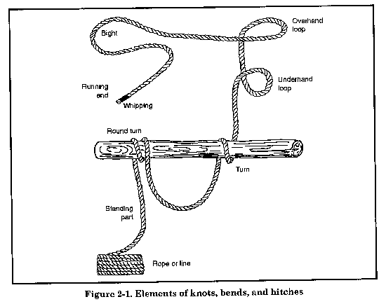
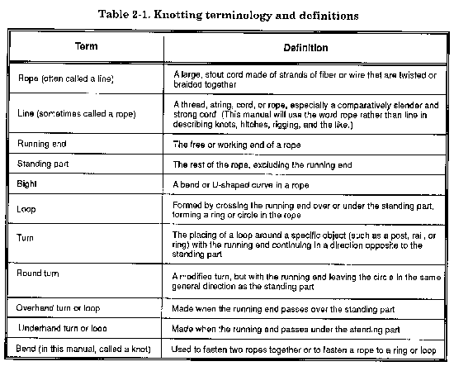
The raw, cut end of a rope has a tendency to untwist and should always be knotted or fastened in some manner to prevent this untwisting. Whipping is one method of fastening the end of the rope to prevent untwisting (see Figure 2-2). A rope is whipped by wrapping the end tightly with a small cord. This method is particularly satisfactory because there is very little increase in the size of the rope. The whipped end of a rope will still thread through blocks or other openings. Before cutting a rope, place two whippings on the rope 1 or 2 inches apart and make the cut between the whippings (see Figure 2-2). This will prevent the cut ends from untwisting immediately after they are cut.
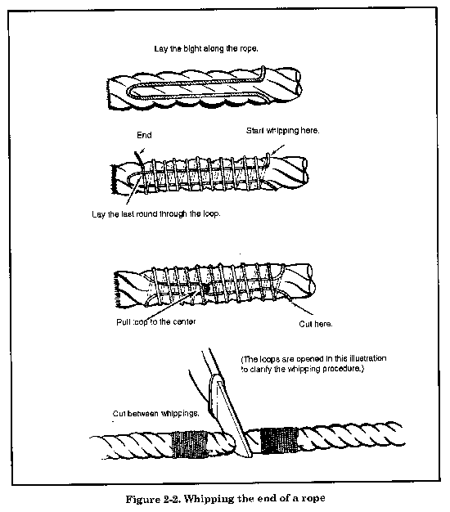

KNOTS
A knot is an interlacement of the parts of one or more flexible bodies, such as cordage rope, forming a lump. It is also any tie or fastening formed with a rope, including bends, hitches, and splices. A knot is often used as a stopper to prevent a rope from passing through an opening.
A good knot must be easy to tie, must hold without slipping, and must be easy to untie. The choice of the best knot, bend, or hitch to use depends largely on the job it has to do. In general, knots can be classified into three groups. They are--
- Knots at the end of a rope.
- Knots for joining two ropes.
- Knots for making loops.

KNOTS AT THE END OF ROPE
Knots at the end of a rope fall into the following categories:
- Overhand knot.
- Figure-eight knot.
Overhand Knot
The overhand knot is the most commonly used and the simplest of all knots (see Figure 2-3). Use an overhand knot to prevent the end of a rope from untwisting, to form a knob at the end of a rope, or to serve as a part of another knot. When tied at the end or standing part of a rope, this knot prevents it from sliding through a block, hole, or another knot. Use it also to increase a person's grip on a rope. This knot reduces the strength of a straight rope by 55 percent.
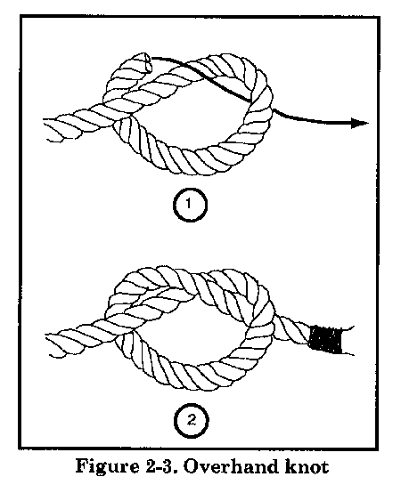
Figure-Eight Knot
Use the figure-eight knot to form a larger knot at the end of a rope than would be formed by an overhand knot (see Figure 2-4). The knot prevents the end of the rope from slipping through a fastening or loop in another rope or from unreeving when reeved through blocks. It is easy to untie.
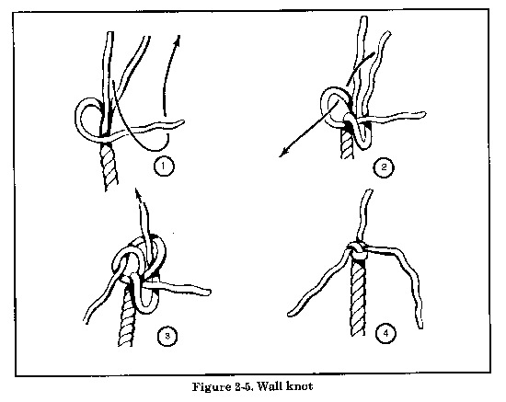

KNOTS FOR JOINING TWO ROPES
Knots for joining two ropes fall into the following categories:
- Square knot.
- Single sheet bend.
Square Knot
Use the square knot to tie two ropes of equal size together so they will not slip (see Figure 2-7). Note that in the square knot, the end and standing part of one rope come out on the same side of the bight formed by the other rope. The square knot will not hold if the ropes are wet or if they are of different sizes. It tightens under strain but can be untied by grasping the ends of the two bights and pulling the knot apart.
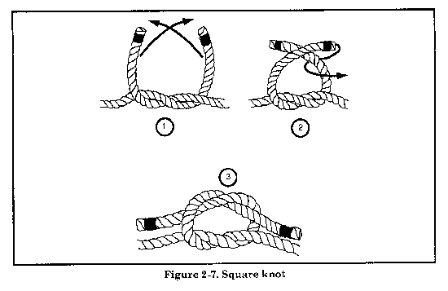
NOTE. It makes no difference whether the first crossing is tied left-over-right or right-over-left as long as the second crossing is tied opposite to the first crossing.
Single Sheet Bend
A single sheet bend, sometimes called a weaver's knot, has two major uses (see Figure 2-8). They are--
- Tying together two ropes of unequal size.
- Tying a rope to an eye.
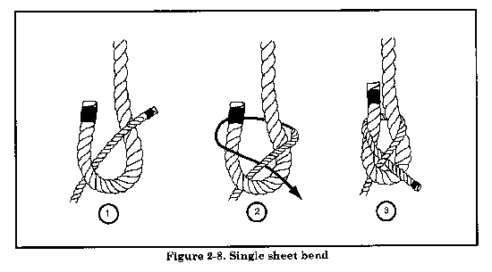
This knot will draw tight but will loosen or slip when the lines are slackened. The single sheet bend is stronger and unties easier than the square knot.

KNOTS FOR MAKING LOOPS
Knots for making loops fall into the following categories:
- Bowline.
Bowline
The bowline is one of the most common knots and has a variety of uses, one of which is the lowering of men and material (see Figure 2-11). It is the best knot for forming a single loop that will not tighten or slip under strain and can be untied easily if each running end is seized to its own standing part. The bowline forms a loop that may be of any length.
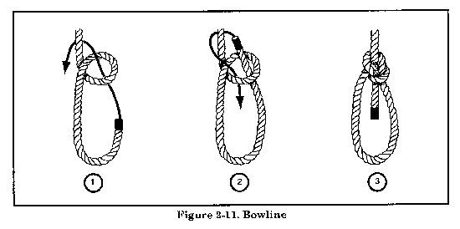

HITCHES
A hitch is any of various knots used to form a temporary noose in a rope or to secure a rope around a timber, pipe, or post so that it will hold temporarily but can be readily undone. The types of hitches are as follows:
- Half hitch.
- Two half hitches.
- Timber hitch.
- Clove hitch.
- Blackwall hitch.

HALF HITCH
Use the half hitch to tie a rope to a timber or to a larger rope (see Figure 2-22, A). It will hold against a steady pull on the standing part of the rope; however, it is not a secure hitch. You can use the half hitch to secure the free end of a rope and as an aid to and the foundation of many knots. For example, it is the start of a timber hitch and a part of the fisherman's knot. It also makes the rolling hitch more secure.
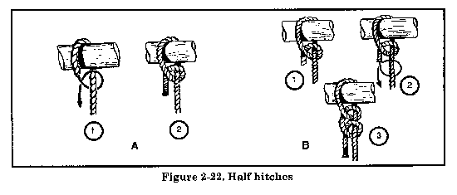

TWO HALF HITCHES
Two half hitches are especially useful for securing the running end of a rope to the standing part (see Figure 2-22, B). If the two hitches are slid together along the standing part to form a single knot, the knot becomes a clove hitch.

TIMBER HITCH
Use the timber hitch to move heavy timber or poles (see Figure 2-24). It is excellent for securing a piece of lumber or similar objects. The pressure of the coils, one over the other, holds the timber securely; the more tension applied, the tighter the hitch becomes about the timber. It will not slip but will readily loosen when the strain is relieved.
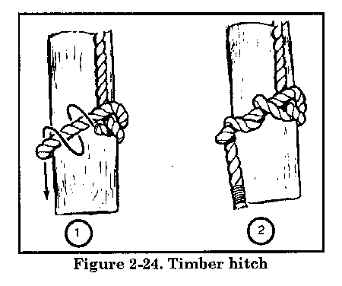

CLOVE HITCH
The clove hitch is one of the most widely used knots (see Figure 2-26). You can use it to fasten a rope to a timber, pipe, or post. You can also use it to make other knots. This knot puts very little strain on the fibers when the rope is put around an object in one continuous direction. You can tie a clove hitch at any point in a rope. If there is not constant tension on the rope, another loop (round of the rope around the object and under the center of the clove hitch) will permit a tightening and slackening motion of the rope.
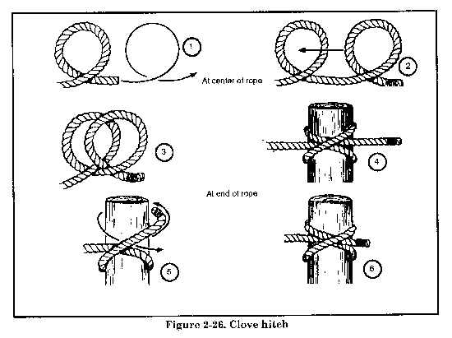

BLACKWALL HITCH
Use the blackwall hitch to fasten a rope to a hook (see Figure 2-31). Generally, use it to attach a rope, temporarily, to a hook or similar object in derrick work. The hitch holds only when subjected to a constant strain or when used in the middle of a rope with both ends secured. Human life and breakable equipment should never be entrusted to the blackwall hitch.
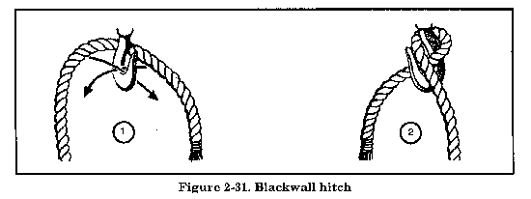

Section II. Splices
Splicing is a method of joining fiber or wire rope by unlaying strands of both ends and interweaving these strands together. The general types of splices are--
- A short splice.
- An eye or side splice.
- A long splice.
- A crown or back splice.
The methods of making all four types of splices are similar. They generally consist of the following basic steps--
- Unlaying the strands of the rope.
- Placing the rope ends together.
- Interweaving the strands and tucking them into the rope.

FIBER-ROPE SPLICES
When one strand of a rope is broken, you cannot repair it by tying the ends together because this would shorten the strand. Repair it by inserting a strand longer than the break and tying the ends together (see Figure 2-39).
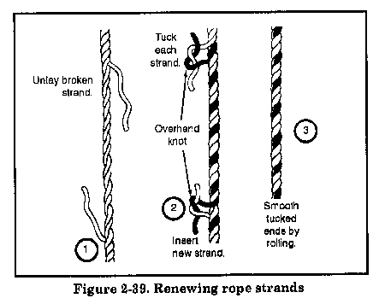

EYE OR SIDE SPLICE
Use the eye or side splice to make a permanent loop in the end of a rope (see Figure 2-41). You can use the loops, made with or without a thimble, to fasten the rope to a ring or hook. Use a thimble to reduce wear. Use this splice also to splice one rope into the side of another. As a permanent loop or eye, no knot can compare with this splice for neatness and efficiency.
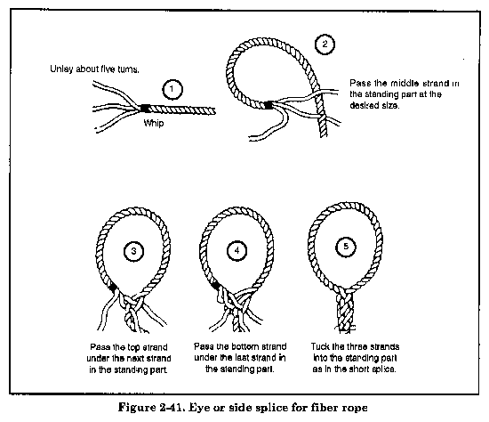

CROWN OR BACK SPLICE
When you are splicing the end of a rope to prevent unlaying, and a slight enlargement of the end is not objectionable, use a crown splice to do this (see Figure 2-43). Do not put any length of rope into service without properly preparing the ends.
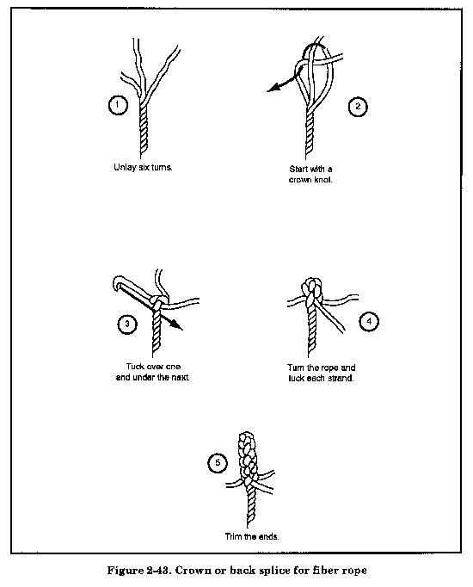

Material excerpted from the U.S. Army publication FM-5-125

