Wood – Concrete Float
Name: ________________________
Date: ________________________

Description:
Make a concrete float (can be used for a concrete project).

What is in the Box?

Materials:
1 – 1x4x12” base
1- 1x2x 4” handle
2 - #6x 1 5/8” deck screws (Philips drive)
120 grit Sandpaper
Wood glue

Tools:
Phillips screwdriver
Steel tape or ruler

Procedure:
- Identify all the tools and materials. Read the entire directions before starting.
- Use the ruler or tape to locate the position of the handle and mark with a pencil. The handle should be centered on the base. This will require some calculations.
- Use the sandpaper to round the edges of the handle. Do not round the bottom of the handle (were it attached to the base). (see photo)
- Use the sandpaper to remove the sharp edges and splinters from the base.
- Apply a small amount of glue to the handle. Spread with your finger or a piece of cardboard. (see photo)
- Attach the handle to the base with the deck screws. They should be flush with the bottom.
- Wipe off any excess glue.
- Double check the project for sharp edges and remove with sandpaper as needed.

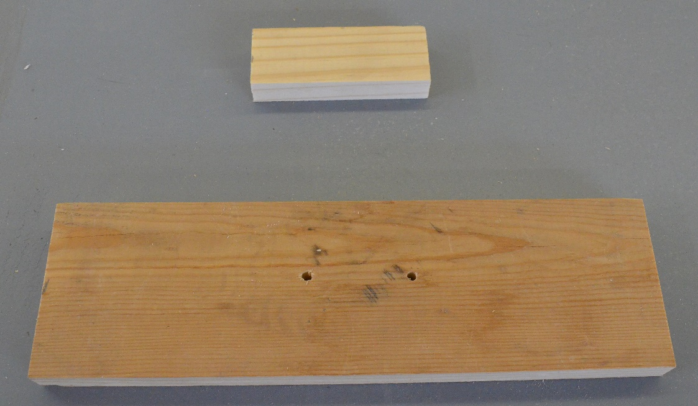
The wood parts.
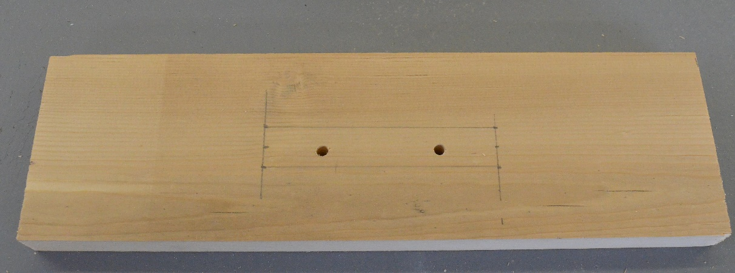
The layout of the handle location.
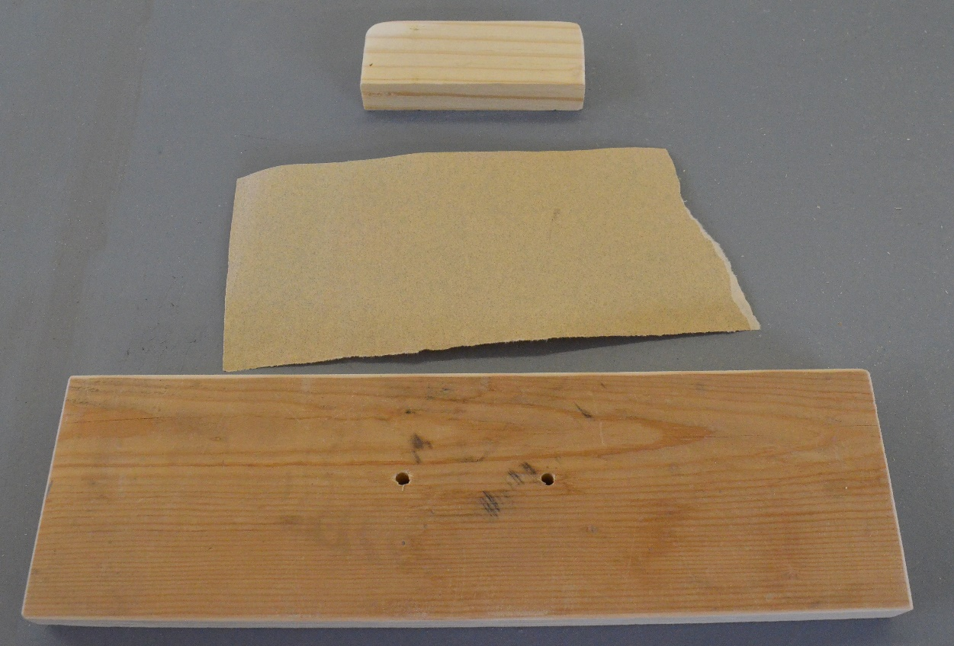
Sanded wood prepared for assembly.

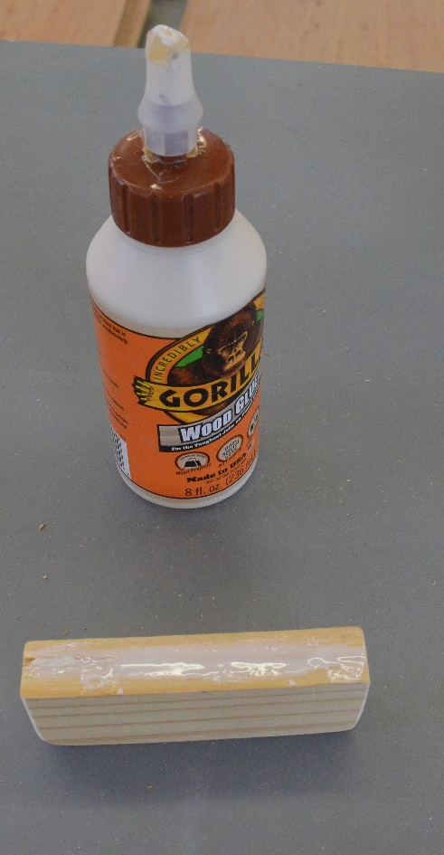
Glue applied to the handle

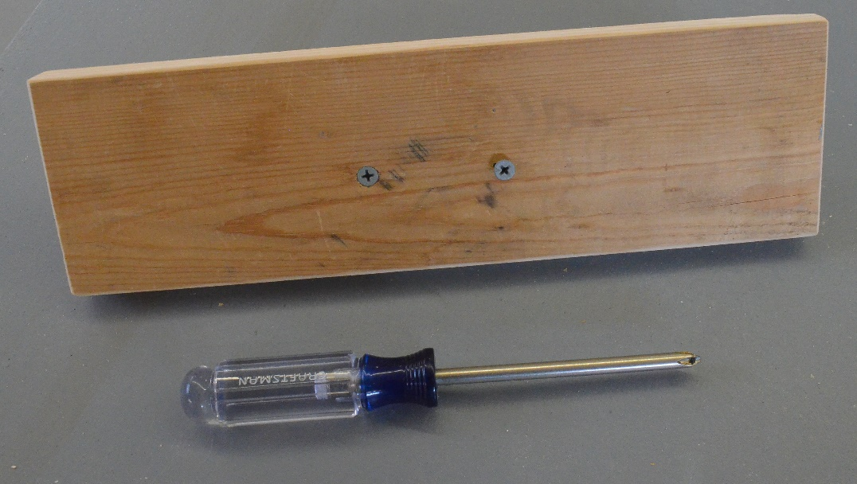
Screws installed from the bottom into the handle
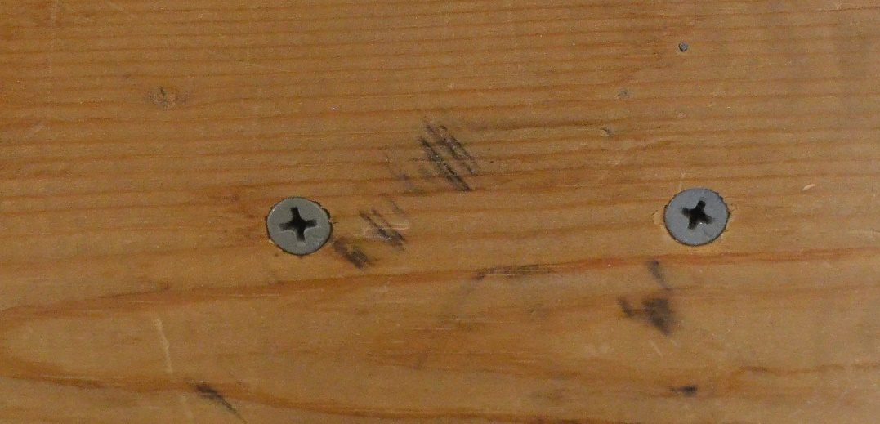
Completed installation with screws flush with the bottom.
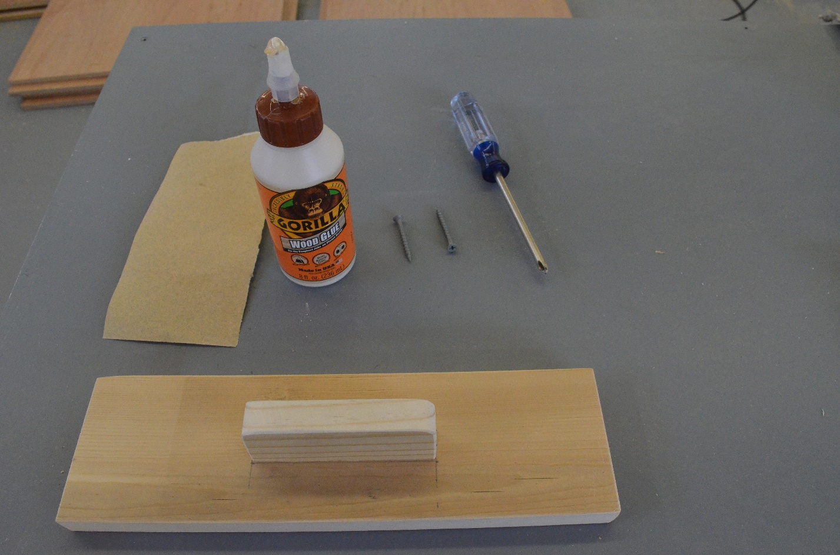
The completed project.

Teacher’s Notes:

- This simple project helps students to learn to follow directions. It includes calculation of the handle location and has enough elements to demonstrate craftsmanship. The 1 x 4 and 1 x 2 are nominal dimensions.
- Precut the parts. These can often be scraps of pine.
- Make a jig to pre-drill the base (3/16” is usually about right) for the screws.
- Questions and/or a grading rubric can be included with the project.

