Rope Halter

Name: ________________________

Date: ________________________

## Description:

A rope halter is useful for leading for many types of animals and is easy to tie.

## What’s in the Box?

## Materials:

12-15’ ½”Laid (twisted) Poly Rope

String

## Procedure:

1. Watch the video: <https://youtu.be/I1bl3SK4UCg>
2. Prepare the ends of the rope. Use the string to whip the ends as shown in the video.   
   See: <https://www.netknots.com/rope_knots/common-whipping>   
   Trim the ends smooth with a knife. Note: the ends may be melted using a gas stove or lighter. BE CAUTIOUS as melted plastic will burn.
3. Mark 14” from the end of the rope.
4. Lay the rope with the short end to your right.
5. Make a loop with a 1/2” opening have the 14” mark at the center of the loop. Keep the short end above the long end.
6. Pass the long end under 1 strand and over 2 strands of the short end, as close to the loop as possible, pull it tight.(Don’t pull your loop closed). **(A)** Keep the rope flat on a table. Next pass the short end under 1 strand and over 2 strands of the long end, as close to the last weave you made as possible, pull it tight. Keep the rope flat on a table.**(B)**,**(C)**

**(A) 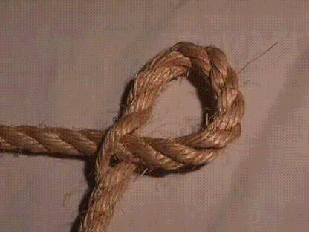 (B)** 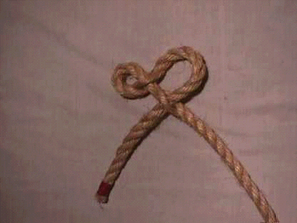  
**(C)** 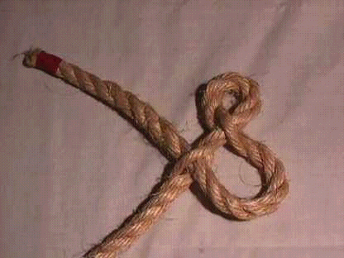

1. Measure from the end of the loop back 2" on the short end of the rope and mark it.
2. Have the loop on your left and the long end above the short end.
3. Keeping the rope flat on a table. Lift the first strand up past the mark. Twist it counter clockwise 1/2 turn.**(D)**

**(D)** 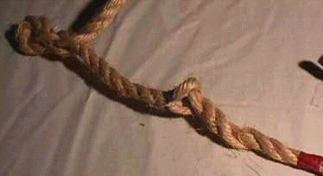

**(E)**

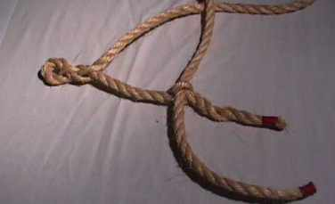

1. From above pass the long end down through the loop. **(E)** Keeping the rope flat on a table. Take the next strand twist it counter clockwise 1/2 turn and put the long end up through the loop. Keep the rope flat on a table. Then twist the next strand counter clockwise 1/2 turn and pass the long end down through the loop. **(G)**,**(H)** *NOTE: The pictures below show the rope end longer than it should be. Ideally the twists should be as close as possible to the hog rings*.

**(G) (H)**

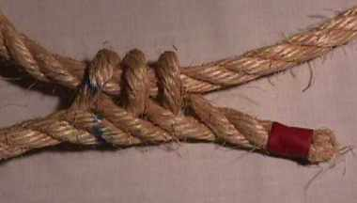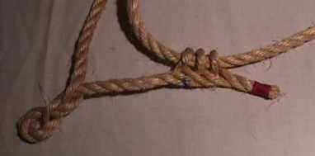

1. Put a hog ring as close to the last loop as possible. Then cut off the extra rope. I didn't have any hog rings at the time we took these pictures, so I couldn't show it on the halter.
2. Pass the long end through the first loop you made. **(I)**

**(I)**

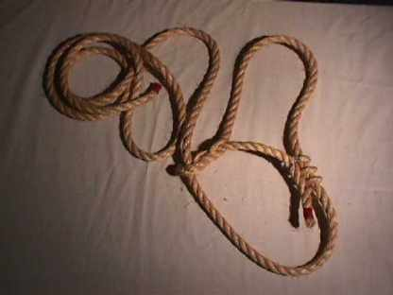

# Teacher’s Notes

Poly or Manilla rope can be used. Ends can be prepared several ways but must be secure. The directions above describe whipping. Hog rings may also be used. Rope can be provided with the ends secure.

A crown knot and back splice can be used to complete the free end. See:

<https://www.animatedknots.com/back-splice-knot>

Size can be altered for different animals:

|  |  |  |  |
| --- | --- | --- | --- |
| Kind and Size of Animal | Size of Rope | Length of Rope | Nose Piece |
| Sheep | ¼ inch | 8 feet | 8 inches |
| Calves | 3/8 inch | 10 feet | 10 inches |
| Cows | ½ inch | 12 feet | 12 inches |
| Horses | 9/16 inch | 15 feet | 15 inches |