PVC Pipe Cord Reel
Name: ________________________
Date: ________________________

Description:
The project is a simple reel made of PVC pipe that can be used for extension cords, ropes, hoses etc. It is a project helps students learn and apply basic plumbing skills and produce a practical product that can be used in the shop. PVC fitting skills are

What’s in the Box?

Materials:
½” Schedule 40 PVC Pipe
½” SSS PVC Tee
½” S PVC Cap
PVC Pipe Cement (small brush), clear will look better
Cable tie

Tools:
Hack Saw
Steel Tape
Shop Rag
Pencil or Marker

Before you start!
PVC cement fumes are hazardous. Use the glue in a ventilated area. Avoid getting glue on your hands. Glue does not wash out of clothes. Cover the work are with news paper as glue will stick to surfaces and is hard to remove.

Cut List
Part | Size | Quantity | Material
Ends | 3” | 4 | ½” Schedule 40 PVC Pipe
Sides | 12 ½” | 2 | ½” Schedule 40 PVC Pipe
Cross Piece | 7 | 2 | ½” Schedule 40 PVC Pipe

Directions:
Gather the necessary PVC pipe materials. Each project needs:
4 ½ ’ – ½” PVC Pipe
4 – ½” PVC Pipe Tee Fittings
4 – ½” PVC Pipe End Caps

- Measuring
See the cut list. Using the steel tape carefully measure the PVC pipe and mark lengths with a pencil or “sharpie”. Lines should neat and straight.

- Cutting
Place PVC pipe on a sawhorse, bench, a porch step and hold it steady. It works best if the place being cut is as close to end of the saw horse as possible. Cut with a hacksaw down the middle of the lines. Be sure to cut square.

Use a shop rag (not your finger) to remove burrs from the ends of PVC pipe that have been cut.

Double check your measurements on the cut pieces.

- Layout
Layout PVC pipe and fittings on a flat surface but do not put them together yet. This helps ensure that pipe is correctly measured and that all fittings are present before putting the project together.

- Assemble
  - When all of the above steps have been completed, you are ready to put your cord reel together. READ all the directions below BEFORE assembling. Follow the order below.
  - Assemble the end pipe to the caps first. Place a small amount of PVC cement on the inside of each fitting and on the end of the pipe. Press the pipe and fitting completely together giving the pipe a ½ twist. HOLD until set.
  - Attach the ends to the tees as shown in the drawing.
  - Attach a side piece to one of the tees. Using a flat surface glue the 2nd tee to the side piece and rotate it flat on the surface so the tees are aligned.
  - Repeat for the second side.
  - Check to see that the tees line up.
  - Glue the cross pieces into the tees on one side.
  - When gluing the two sides together you must glue both tees at the same time and you will not be able to twist the pipe in the fitting.

- Attach the plug end of the cord to the reel with a cable tie (can be left loose).
- Complete the worksheet.

Drawing/Photo:
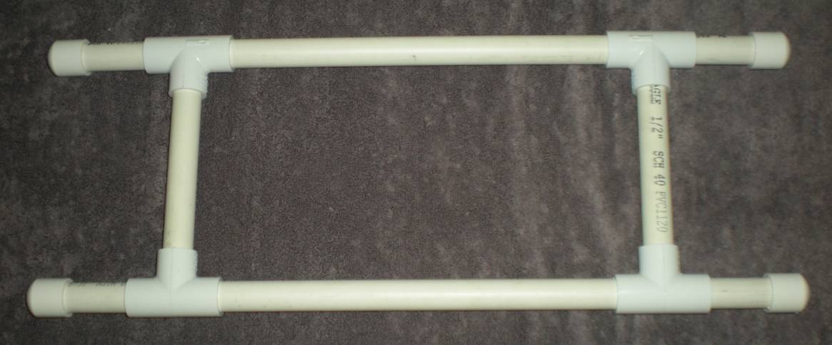
Project assembled.

21”
8 ½ ”
13 ½ ”
(Dimensions are approximate as pipe fittings will vary.)

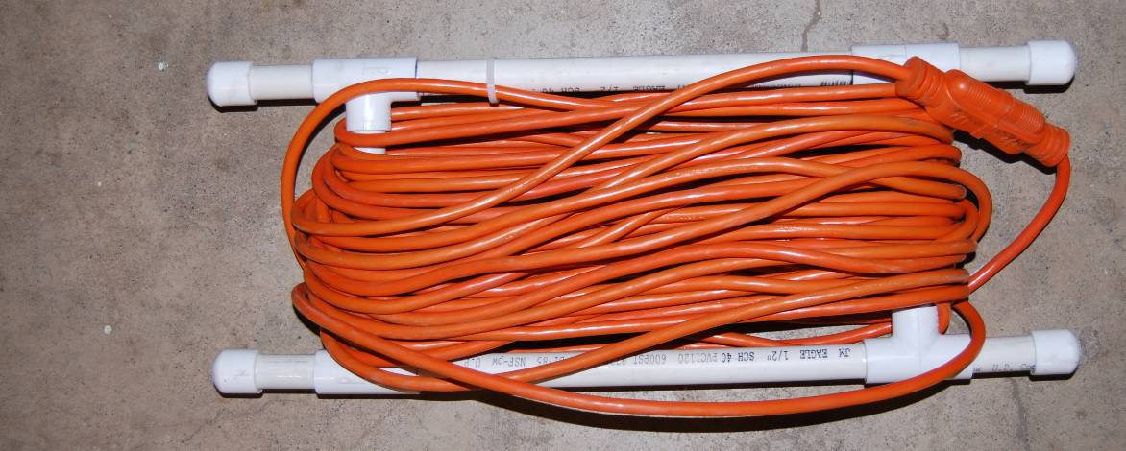
Finished Project with a cord.

PVC Pipe Cord Reel Student Worksheet:
Name: ________________________
Date: ________________________

Complete this worksheet prior to starting the project.
- What size and type of pipe is used for this project? _________________________________
- Draw a sketch of the project and label the dimensions of each pipe.

- How many feet of pipe will you need to complete this project? _______________________
- This project requires _____ different types of pipe fittings. List the name of each fitting, and how many of each you will need:
___________________________________________________________________________
- What tools are required to complete this project?
_________________ _________________ __________________
What step is important after cutting your PVC pipe with a saw, and why? ___________________________________________________________________________
___________________________________________________________________________

Teacher’s Notes:
Each student needs 4 ½”’ of PVC pipe to complete this project. You may choose to pre-measure and cut the correct amount for each student, or give them the dimensions of the finished project and ask them to figure out how much they need. The last choice obviously requires more thought and skills on the part of the student. Buy fittings in bulk or contractor’s packs to save money.

