Measuring Objects
Name: ________________________
Date: ________________________

Description:
Almost all shop projects require accurate measuring.
Common Measuring Tools:
Study the tools below. You should be able to identify these by name.

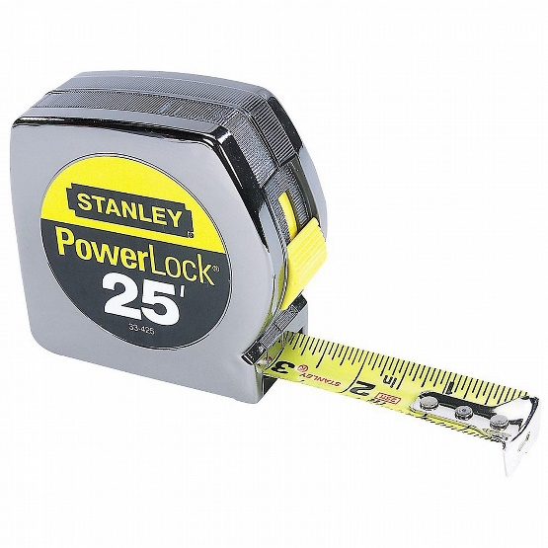Steel Tape
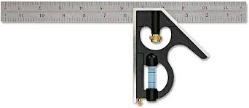

Combination Square
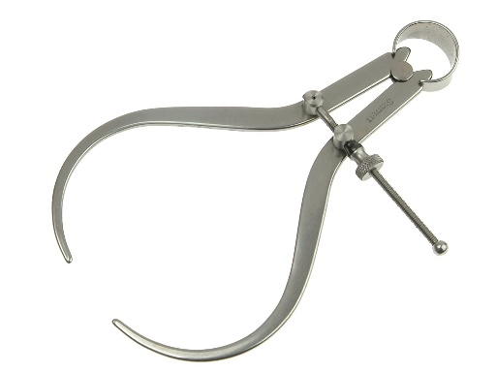
Outside Calipers
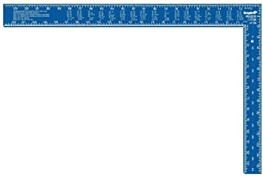
Framing Square
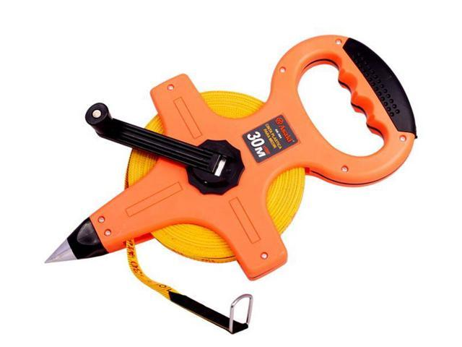
Fiberglass Tape

Measurement Scale:
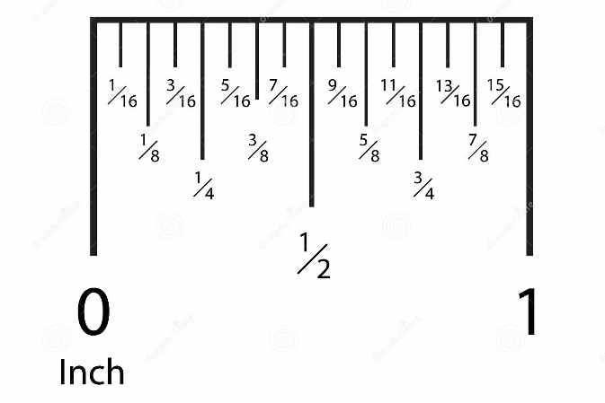

What’s in the Box?

Materials:
5 – unknown items (labeled A-E)

Tools:
Steel Tape
Combination Square (optional)

Procedure:
- Review the measuring scale. Note how the line length varies.
- Find the following on the tape:
  - 1 ¾”
  - 5 ½”
  - 7 ¼”
  - 10 1/8”
  - 4 3/16”
- Compare your measurements to those in the photos below.
  - 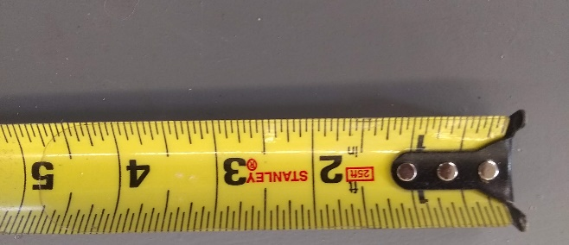
  - 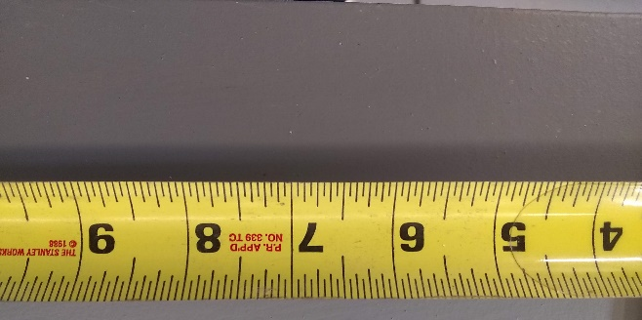
  - 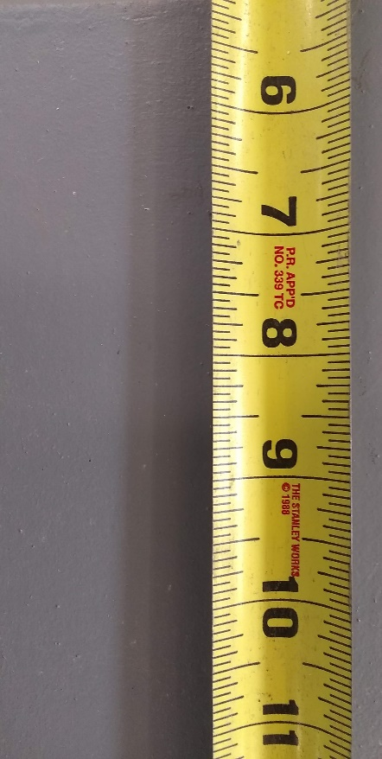
  - 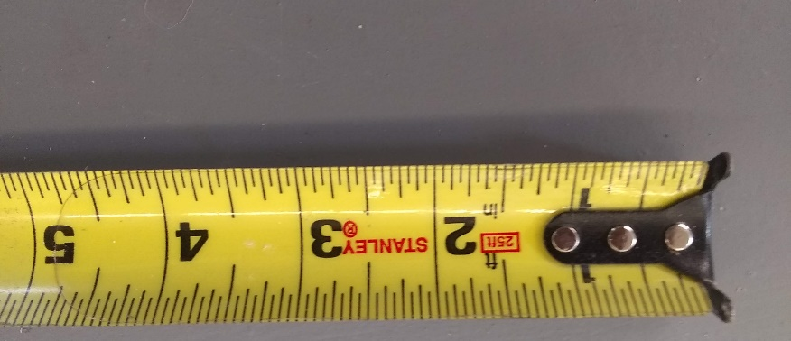
- Complete the table below by measuring the items in the box.

Letter | Description | What to measure | Measurement
A
B
C
D
E

Teacher’s Notes

The number of items to measure can be varied. Multiple sets can be used (identify so you can keep a key). Below is an example:

Letter | Description | What to measure | Measurement
A | Plywood | Thickness, length and width to nearest ¼” | ½” x 6 ½” x 8”
B | Pine board | Length to nearest 1/8” | 12 3/8”
C | Fir | Thickness, length and width to nearest ¼” | 1 ½” x 3 ½” x 4 ½”
D | Sheet metal | Length and width to nearest 1/16” | 3 3/16 x 4 ½”
E | Bolt | Diameter to nearest 1/6” | 3/8”

