Import Scores from a Google Sheet into the Tabulations Program.

Google Sheet
In Google create the score sheet. The headings must be “school”, “name”, and the classs numbers setup in the tabulations program. Class number may be entered as “01” as listed in the tabulations program or just “1”. They will be converted when the file is imported. Teams will be separated by the school. “A” and “B” teams must have a different school. If scores are coming from Google Forms plan to cut and paste results into a single sheet.
NOTE if the score is a “placing”: Placings may be the left three places (ex. 123) or all 4 (ex. 1234). They will be converted to the left 3 upon import.
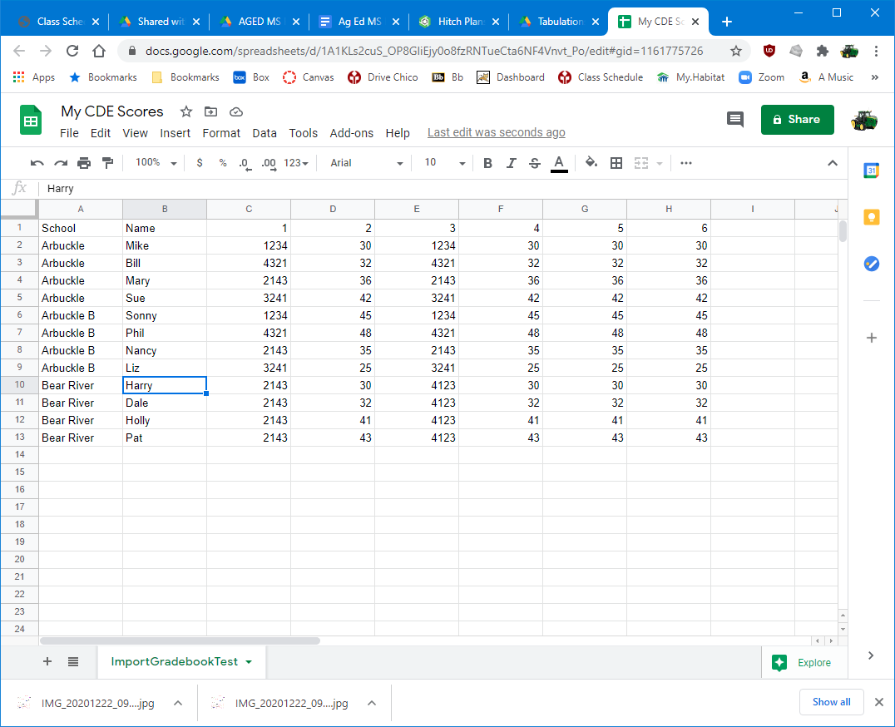

Download the file as a comma separated values file (File | Download).
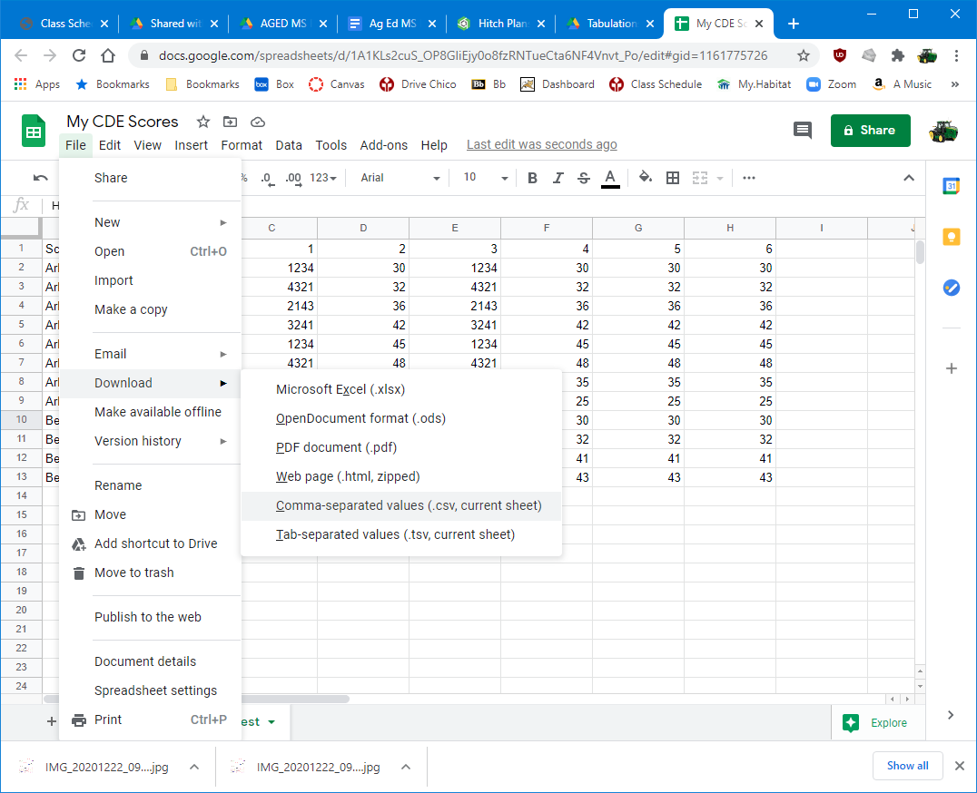

Open the exported file in Excel and double check the format.
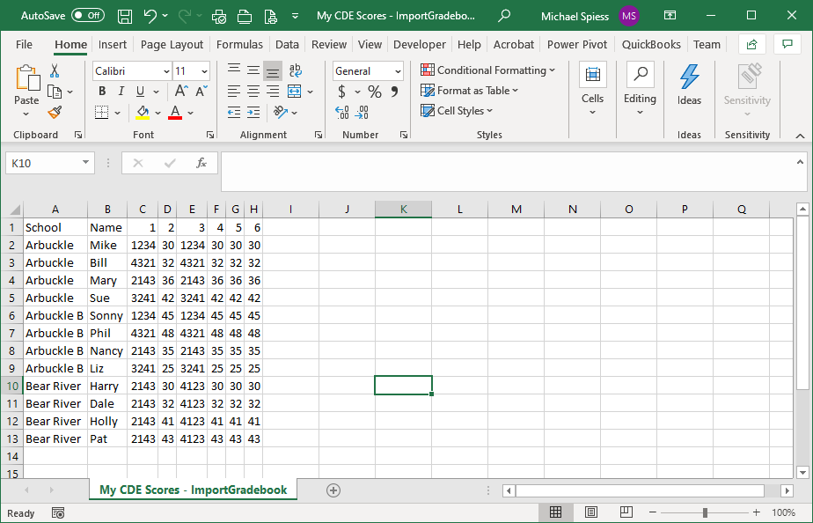
Exported File

Tabs setup
- Set up classes to match what you are doing. Omit classes you will not use (or hide)
- Adjust class multipliers to properly weight classes.
- All classes should be type “Normal”. Judging box should not be checked UNLESS You are importing placings (ex. 4231).
- If placing classes are used then enter official scoring (Official Score | Enter Official Placing).

Import & Results
Use of the tabulations checklist is encouraged.
- From the admin menu choose Import Gradebook.
- Check the teams and names (Setup | Contestant List)
- Review the raw scores (Tabulation | Raw scores). Lists scores as imported.
- Review Draft Results (Tabulations | Draft Results). Shows scores with multipliers.
- Print Results as desired. (Use PDF format to send out).
- Print certificates if desired. Notewrra that these can be printed to PDF and sent electronically.

