Electrical Wiring Projects
Name:_____________________
Date: _____________________

Description:
Students will learn how to properly install and wire using common industrial devices on an electrical Board. Students will practice using common electrical testers.

Materials*:
½ CC Plywood board (8 per sheet)
1 – 4 breaker panel with a quad breaker that contains 2-15A breakers and 1-2 pole 20A breakers. This panel simulates a service entrance panel (SEP).
3 – 4” sq. Electrical boxes with ½” KO
2- ½” EMT Box connectors
2- ½” PVC Box connectors
8” of ½” EMT
8” of ½” PVC Conduit
4 – Grounding screws installed in the box
3 – Single gang ½” plaster ring
1 – 2 gang ½” plaster ring
1 – 3” round ½” plaster ring
3 – 4” square blank cover.
5 – ½” NM cable clamps
2 – Duplex Receptacle
2- Lamp holder with pig tails (must be connectable with wire nuts like common light fixtures) and mountable in the round plaster ring.
2 – SPST switch
2 – 3 way switches SPDP
1 – 4 way switch DPDT
Note: Mounting screws must be provided for the plaster rings (#8)
Boxes should be centered on the board and placed 8” apart (approximately 12” O.C.).
*Not all supplies will be used for each scenario.

Tools:
Screwdriver
Needle Nose Pliers
Wire cutter/stripper

Procedure:
- Review the rules for wiring (text book). Key points are:
  - Color coding of wire and terminals. Green=ground, white=neutral, other colors are hot. Brass terminals are hot wires, silver terminals are neutral, green terminals are ground.
  - 6” of free conductor.
  - Use of wire nuts: tight and no bare wire showing.
  - Grounding: boxes and devices.
  - Proper connection to a screw terminal: Clockwise, loop ¾ around, no insulation under the screw, no bare wire past the device.
- Complete the worksheet.
- Wire the assigned project.
  - Determine the proper circuit and how you will wire it BEFORE you start wiring.
  - Wire the ground wires first.
- Double check that you have followed the rules and that the wiring is neat.
- Secure the devices to the boxes with screws for testing.
- Attach a temporary power cord using wire nuts. OBSERVE color-coding.
- Using the Testing Circuit Breaker box, plug in your board and test the circuit using a lamp and/or a duplex receptacle tester. Have this portion graded.
- Disconnect your board. Use a piece of tape to label the board with your name. Remove the screws from the devices and turn in the board for grading.

Terms:
- Stub out: Leave 6” of conductor in the box unconnected for a future connection.
- Rough in: Boxes are grounded and wires connected as needed in boxes. Plaster rings are installed. Devices are left unconnected.

Notes:_________________________________________________________________________________________ ________________________________________________________________________________________________________________________________________________________________________________________________________________________________________________________________________________________________________________________________________________________________________________________________________________________________________________________________________________________________________________________________________________________________________________________________________________________________________________________________________________________________________________________________________________________________________________________________________

The Wiring Board:
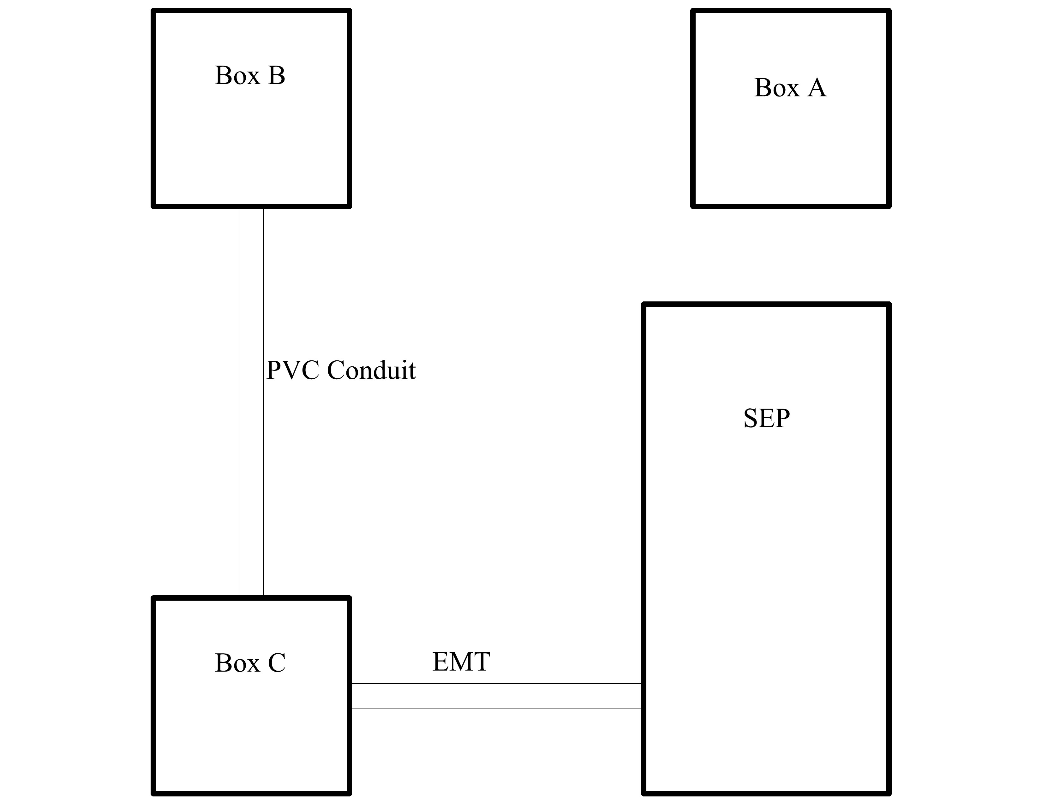
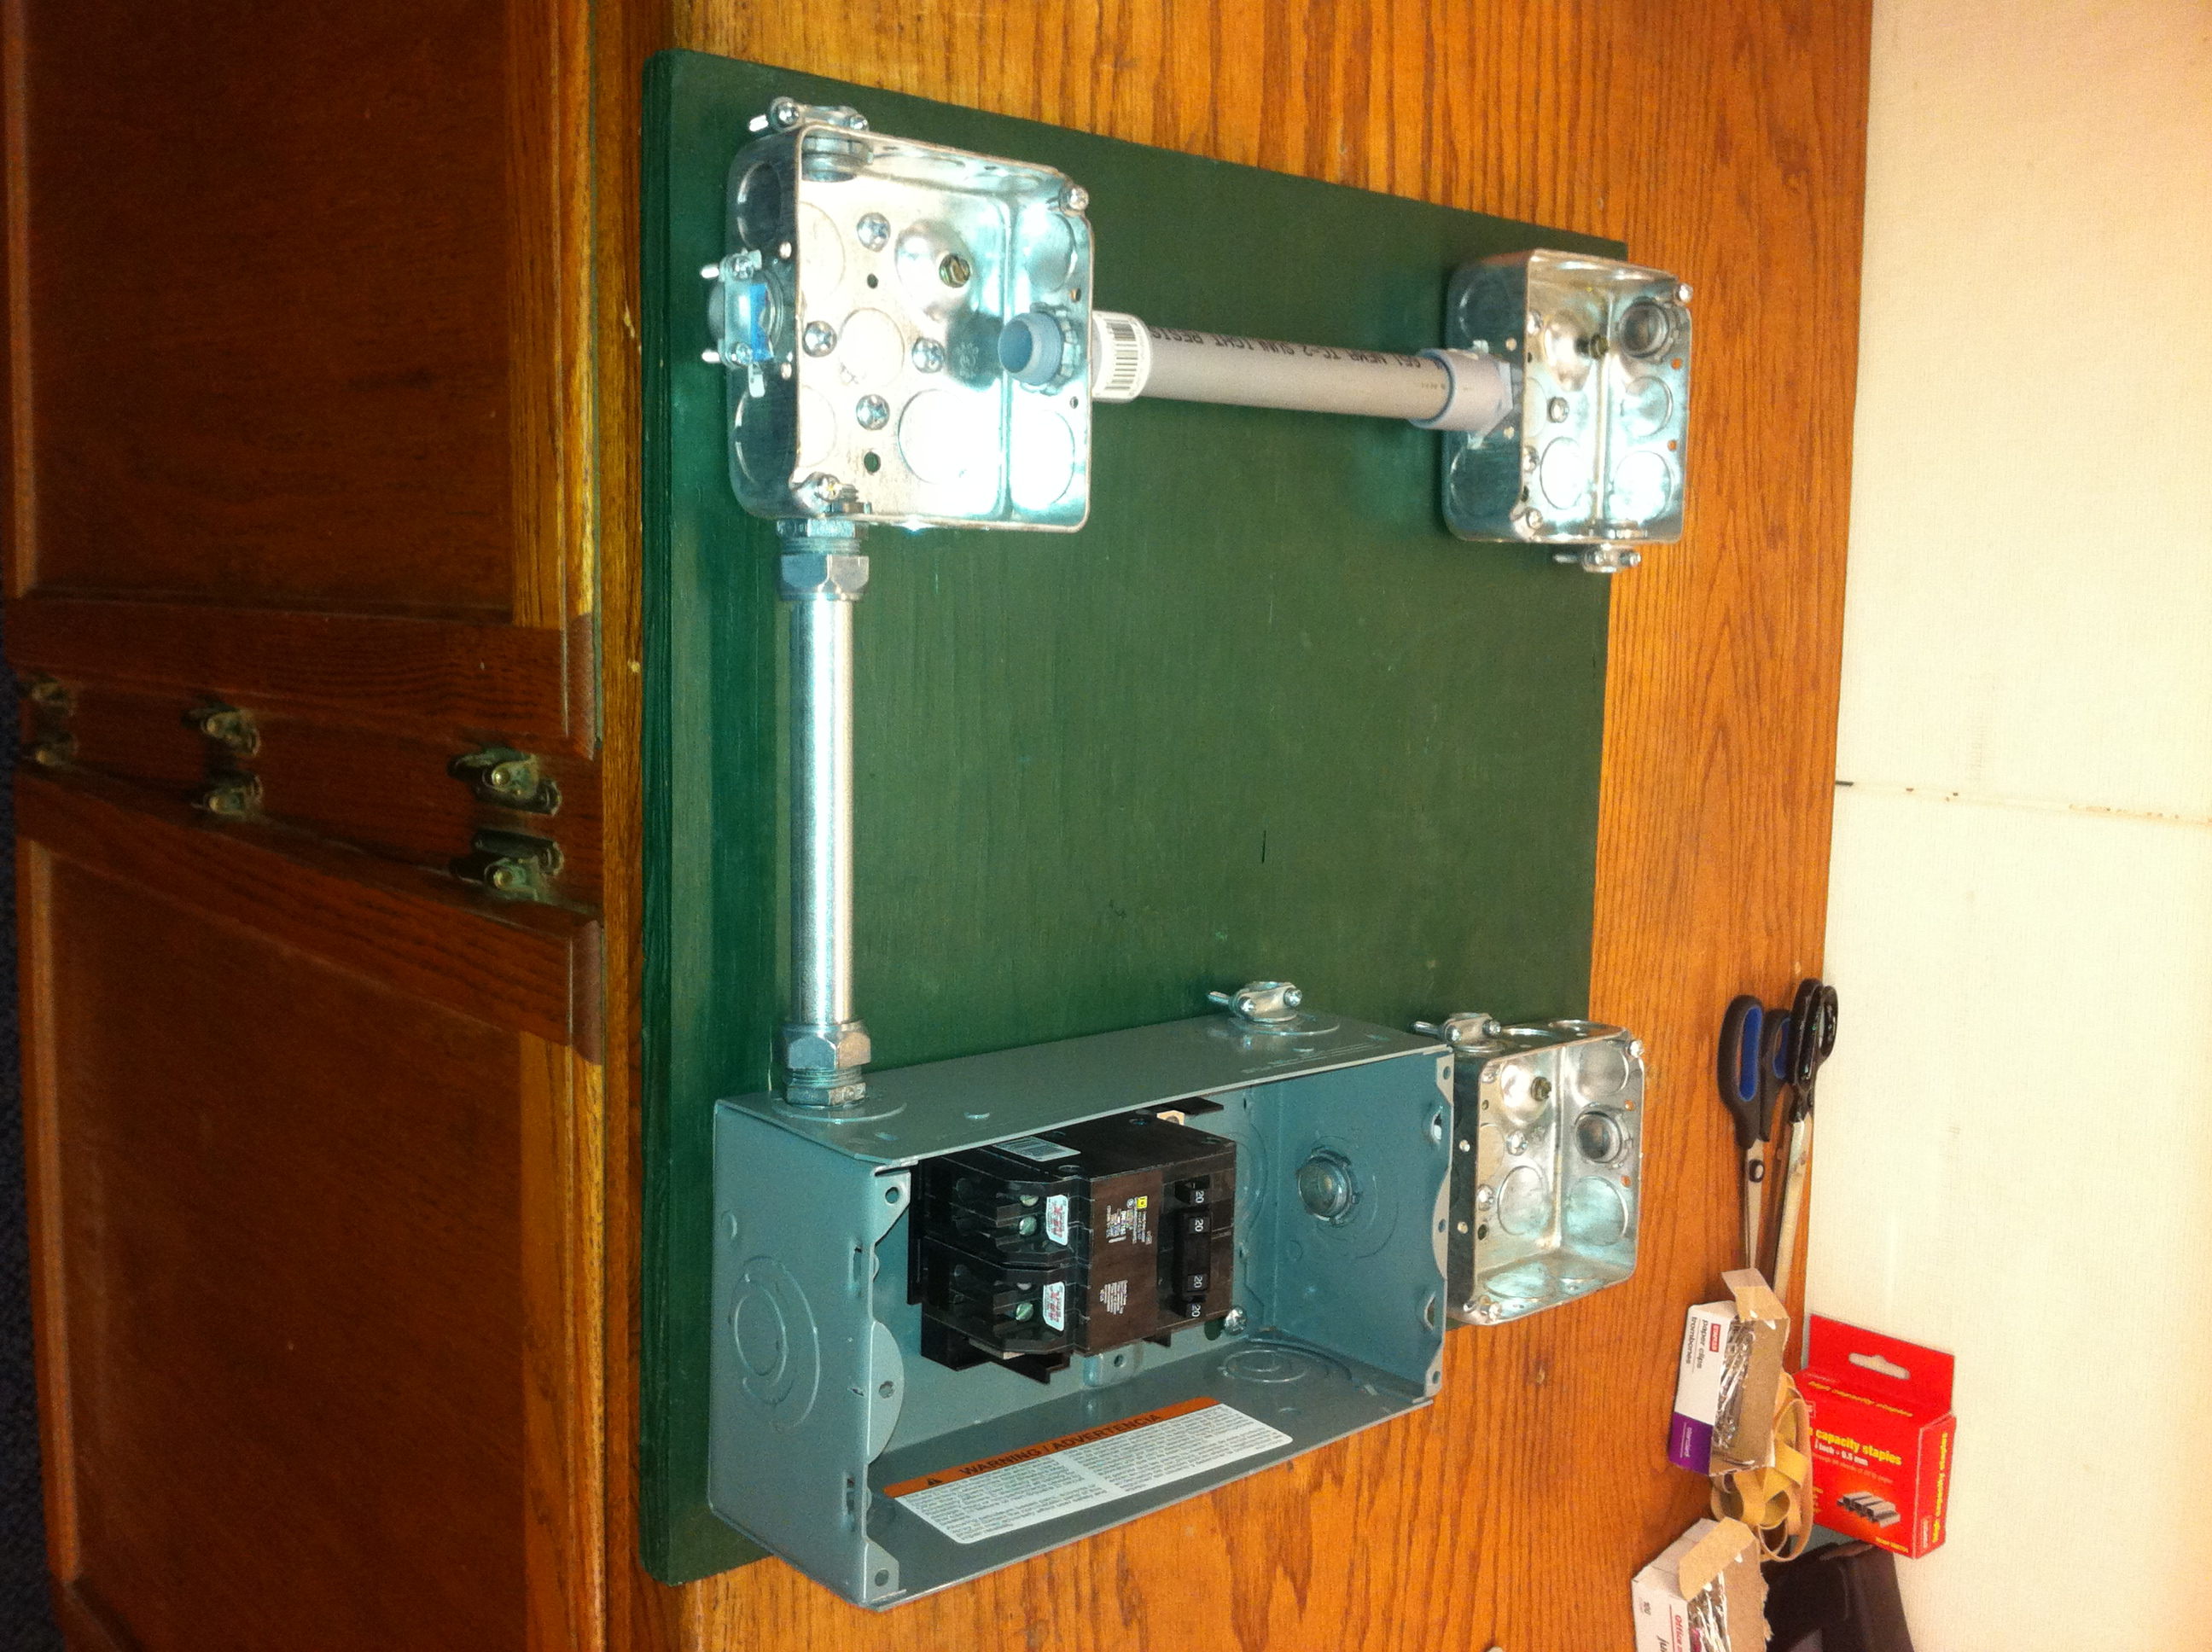

Wiring Projects:
- Box should have plaster rings or covers as per code.
- All circuits should be connected to a circuit breaker unless noted.
- Panel is assumed to be grounded.
Complete one or more of the scenarios below.

Service Entrance Wiring:
- Using the provided NM 10-3 cable wire the panel as if it were a service entrance. In this case ground and neutral conductors are connected together and the buss bar is connected to the panel ground.
- Using the provided NM 10-3 cable wire the panel as if it were a sub panel. In this case ground and neutral conductors are NOT connected together and the buss bar is NOT connected to the panel ground.
- Using the provided 10 gauge THHN conductor wire the panel as if it were a sub panel. Stub out wire in box C.
- Using the provided 10 gauge THHN conductor connect the panel as if it were a service entrance. Stub out wire in box C.

Simple Circuits:
- Rough in a lamp in Box A controlled by a switch in Box B.
Switch
Lamp
- Wire a DR in Box C.
DR
- Wire a Lamp in Box B controlled by a switch in Box C.
Lamp
Switch
- Wire a lamp in Box A controlled by a switch in Box B. Power source is box A
Switch
Lamp

More Complex Circuits:
- Wire a DR in Box B and Box C on separate circuits.
DR
DR
- Wire a DR in Box B and Box C on the same circuit.
- Stub out wire in Box C for a 20A 240V load. (Stub out wires)
- Stub out wire in Box A for a 20A 240V load. (Stub out wires). NM Cable.
- Wire a lamp in box A controlled by 3 three way switches in box B and C. Power for the circuit is from box A.
3 Way
Lamp
3 Way
- Wire a lamp in box A controlled by 3 three way switches in box B and C. Power for the circuit is from box C.
- Install two DR’s in Box C on separate circuits.
DR & DR
- Install a switch and DR in Box B. Install a lamp in Box A controlled by the switch using NM cable.
Switch
DR
Lamp
- Install a switch and DR in Box C. Install a lamp in Box B controlled by the switch.
Lamp
Switch
DR
- Rough in wiring in box C for the receptacle device below and a DR.
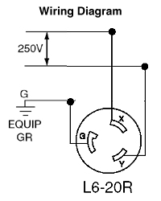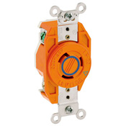

Electrical Wiring Worksheet
Name: ________________________
Date: ________________________

- What do the following wire colors indicate (hot, neutral, ground)?
  - White:_________________
  - Green:_________________
  - Black:__________________
  - Red:___________________
- How much free conductor is required for device wiring? _______________
- What do the following terminals (hot, neutral, ground)?
  - Brass:_________________
  - Silver:_________________
  - Green:_________________
- What type of wire is used in the conduit?___________________________________
- What direction does the wire wrap on a screw terminal? _______________________
- Neatly diagram your circuit. Show wire connections with a line and label or use the wire color.

Grading Rubric:
CRITERIA | POSSIBLE | Score
Proper device location | 5
Properly grounded | 5
Wire color coding | 5
Screw terminals | 5
Wire nuts | 5
Workmanship(no nicks, clockwise loops, neat) | 5
Correct circuit (works) | 5
TOTAL | 35

Score
Worksheet (10)
Projects
Total

Electrical Wiring Teachers Notes:
For more details of the wiring board look in the CATA Ag Mechanics Curricular Code. With these boards you can make many circuit variations.

Agricultural Standards Met:
6.0 Health and Safety. Students understand health and safety policies, procedures, regulations, and practices, including the use of equipment and handling of hazardous materials:
B1.0 Students understand personal and group safety:
B1.1 Practice the rules for personal and group safety while working in an agricultural mechanics environment.
B1.2 Know the relationship between accepted shop management procedures and a safe working environment.
B3.0 Students understand the basic electricity principles and wiring practices commonly used in agriculture:
B3.3 Analyze and correct basic circuit problems (e.g., open circuits, short circuits, incorrect grounding).
B3.4 Understand proper basic electrical circuit and wiring techniques with nonmetallic cable and conduit as defined by the National Electric Code.
B3.5 Interpret basic agricultural electrical plans.

Objectives:
By properly completing this project, students will be able to:
- Identify the allowable wire color for the types of conductors.
- Explain the correct names of materials.
- Correctly use of wire nuts.
- Can properly wire a circuit.
- Can solve the problem if circuit is not working.
- Demonstrate how to properly wire an electrical device.

Alternative Tools/Methods/Materials:
Similar projects can be developed by using boxes mounted to 2 x 4s. If only NM cable wiring is used then plastic boxes can be used. The project can be modified by changing the scenarios.

Safety Review:
- All power is turned off or disconnected
- Do not use wire with any nicks in it!
- Do not touch electrical with wet hands of feet.
- Check switches, outlets, fixtures or extension cords for damage before using
- Disconnect power source is burning smell or hot.
- Properly wire and double check before testing it!
- Working with electricity can be dangerous. However, electricity can be safe if properly respected.

Project Time:
For 1 project:
Demonstration: | 20 minutes
Build: | 30 -60 minutes

Demonstration Notes
- Review electrical section of an Ag Mechanics text.
- Review the types of wire, terms, and names of devices.
- Cover the basic rules of wiring and discuss the National Electric Code:
  - Color coding of wire and terminals
  - 6” of free conductor – reason: allows replacement of devices without having to replace the wire.
  - Use of wire nuts: tight and no bare wire showing.
  - Grounding: boxes and devices.
  - Proper connection to a screw terminal: Clockwise, loop ¾ around, no insulation under the screw, no bare wire past the device.
- Cover making “pig tails” to connect devices to multiple wires.
- Cover basic circuits. Tip: Have students trace a few complete circuits.
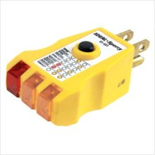
- How to make a proper eye for terminals (bend back 90º first). Practice this and look like a pro!
- Build a board with a GFCI, a switch, and a power cord to use for testing. This will protect the student and you if the circuit is bad.
- Temporary power cords are simply a piece of 14/3 NM cable with a cord cap wired to one end.
- Use a simple circuit tester. When testing duplex receptacles.
- At least loosely screw in the devices before connecting to power so they cannot ground to the metal boxes or be touched.
- Circuits are easily visually checked. It is OK to connect an improper circuit. When it doesn’t work ask the student to troubleshoot. Sometimes they learn more this way!

Bill of Materials:
Consumables for all projects. Materials in full spools as shown below will build approximately 100 projects. Wire can often be reused.

Materials (per board):
These are basically non-consumable. Prices are 2010 (Home Depot).
Quantity | Description | Price | Amount
0.125 | ½ CC Plywood board (8 per sheet) | $ 26.00 | $ 3.25
1 | Panel | $ $15.00 | $ 15.00
1 | Quad breaker | $ 18.00 | $ 18.00
3 | 4” sq. Electrical boxes with ½” KO | $ 0.97 | $ 2.91
2 | ½” EMT Box connectors | $ 1.91 | $ 3.82
2 | ½” PVC Box connectors | $ 1.33 | $ 2.66
scrap | 8” of ½” EMT | NA
scrap | 8” of ½” PVC Conduit | NA
4 | Grounding screws installed in the box | $ 0.08 | $ 0.32
3 | Single gang ½” plaster ring | $ 0.97 | $ 2.91
1 | 3” round ½” plaster ring | $ 1.14 | $ 1.14
3 | 4” square blank cover. | $ 0.57 | $ 1.71
5 | ½” NM cable clamps | $ 0.40 | $ 2.00
1 | Duplex Receptacle | $ 0.59 | $ 0.59
2 | Lamp holder with pig tails and mountable in the round plaster ring. | $ 1.19 | $ 2.38
1 | switch | $ 0.69 | $ 0.69
2 | 3 way switches | $ 1.48 | $ 2.96
500 | Yellow wire nuts | $ 4.59 | $ 4.59

